DESIGN, ANALYSIS AND FABRICATION OF A PNEUMATICALLY
ACTUATED BELOW-HIP ORTHOSIS FOR PARTIALLY PARALYSED SUBJECTS
DESIGN PROJECT REPORT

Of
5th Semester B.Tech
In

MECHANICAL ENGINEERING

2016-20 batch

Of

APJ Abdul Kalam Technological University

By

ARUN JOSEPH [MGP16ME033]



DEPARTMENT OF MECHANICAL ENGINEERING
Saintgits College of Engineering
Kottukulam Hills, Pathamuttom, Kottayam, Kerala 686532

November 2018
DEPARTMENT OF MECHANICAL ENGINEERING SAINTGITS COLLEGE OF ENGINEERING
Kottukulam Hills, Pathamuttom P.O, Kottayam-686532, Kerala
Tel : +91-481-2436169,170, Fax : +91-481-2430349
Website : www.saintgits.org

CERTIFICATE

This is to certify that this design report entitled “DESIGN, ANALYSIS AND FABRICATION OF A PNEUMATICALLY ACTUATED BELOW-HIP ORTHOSIS FOR PARTIALLY PARALYSED SUBJECTS” is a bonafide record of the design project done by Mr. AKHIL BINU, Mr. AKHIL SAJEEV,Mr. ANAND MATHEW JAMES,Mr. ARUN JOSEPH,Mr. BINS SEBASTIAN of fifth semester bearing Reg No: MGP16ME 012,013,025,033,047 respectively, towards the partial fulfillment of the requirements for the award of B.Tech.degree in Mechanical Engineering of APJ Abdul Kalam Technological University during the academic year 2018- 2019.

Dr. CHACKO PRENO KOSHY Dr. JACOB T VARGHESE
Design Project Guide Professor & Head of the Department
Dept. of Mechanical Engineering Dept. of Mechanical Engineering

ACKNOWLEDGEMENT

First and foremost, we thankfully acknowledge our Principal Dr. M.D. MATHEW for giving us an opportunity to present the Design Project Work

The constant encouragement and timely support rendered by our Professor and Head of Department, Dr. JACOB T VARGHESE is deeply remembered.

We express our heartfelt gratitude to my mentor, Dr. CHACKO PRENO KOSHY, Assistant Professor, Department of Mechanical Engineering, for his valuable guidance, support and encouragement during the course of the work and in the preparation of the report. I have greatly benefited from his experience and knowledge.

The help extended by all other staff members of the department are remembered with gratitude.

We also remember with thanks, our parents,all our friends and well-wishers for their encouragement and support.

Above all, We would like to express our profound gratitude to God Almighty for His immense blessings upon me that led to the successful completion of this work.

ABSTRACT
As per the recent observations in the medical field, the chances of people getting paralyzed are getting increased due to increasing number of road accidents and other life style diseases. Consequently, creating a huge to challenge to comfortable existence of the afflicted population in the world, since they are not able to commute their own and require special care to get their routines done.
Considering this stance of the afflicted people in the society and the wide demand for devices that help to mitigate this problem, the design of ‘Tread Assistor’ is proposed. This system is designed for partially paralyzed people. An exo-frame mechanism incorporated with servo motors is designed and it is to be attached to the paralysed limbs from the hip.
Aluminium metal is used as the frame material in the design. In order for the partially paralysed subjects to obtain desired movement in the required manner, the accuracy of servo motor in creating desirable angular displacement is made use of. Accurate values of angles of rotation of knee, hip and ankle are obtained from analysis .These angles can be developed in the exo-frame by rotating the servo motor attached to it. Weight of afflict is balanced by support sticks which is also incorporated with manual controllers.
The design has been done in a way to improve the efficiency of the proposed system at an affordable expenditure.

CONTENTS

Page No.

ACKNOWLEDGEMENTS (ii)
ABSTRACT (iii)
LIST OF NOTATIONS (v)
LIST OF FIGURES (vi)
LIST OF TABLES (vii)

Chapter 1 INTRODUCTION 1
1.1 Average value based model development 2
1.1.1 Linear Mathematical Modeling 2

Chapter 2 LITERATURE REVIEW 6

Chapter 3 EXPERIMENTAL METHODOLOGY 7
3.2 Modeling Approaches
3.2.1 Kinematic and kinetic analysis using
Newton’s equations of motion

Chapter 4 DESIGN PROCESS 9
4.1 Problem identification 9
4.2 Problem definition 9
4.3 Design functions and constraints 9
4.4 Data collected 9
4.5 Ideation 10
4.6 Preliminary design 10
4.7 Detailed design 10
4.8 Design for posturing,safety,recovery 10

4.9 Aesthetics and ergonomics 11
4.10 Standardisation 11
4.10 Standardisation 11
4.11 Prototyping 11
4.12 Analysis 11
4.13 Communication 12
4.14 Design modification 12

Chapter 5 CONCLUSIONS 16

REFERENCES 17
INTERACTION AND DISCUSSIONS 18
LIST OF NOTATIONS
- N1- Base average
- N2 -First variational term
- N3 -Second variational term
- FX - Reaction force acting along x direction,
- FY - Reaction force acting along y direction,
- ax- Acceleration acting in x direction,
- ay - Acceleration acting in y direction,
- m- Mass of the leg,
- M -Moment about centre of gravity
- I - Moment of inertia
- α - Angular acceleration of the leg.

LIST OF FIGURES

Fig. No. Title Page No.

3.1 Resolved forces and moments on a left leg segment 5
during swing phase
4.1 3D Design of the proposed walk assistor 10
LIST OF TABLES

Table Page No.

1.1 Calculation of moment and reaction force 5
for 2 ,3 and 4 frames

CHAPTER 1
INTRODUCTION
Locomotion have prior importance for any human beings in their life. Hence walking assistive devices are always a boon for the afflicted human beings. At present, varieties of walking devices are widely available for different gait irregularities. But the most preferred one is selected depending on the suitable gait characteristics of a subject that it can exhibit. The present walking assistive devices which are more popular and widely available in markets viz., HAL-Hybrid Assistive Limb, exoskeleton, have more focus on the suitability of gait characteristics. Further improvements can be made on walking assist devices if and only if a perfect gait analysis is carried out and new methods are implemented. A robot suit HAL (hybrid assistive limb) has been developed by T Hayashi et.al, as an walking assistive device for lower limbs. Here the assistive device will develop torque corresponding to myoelectricity signal which has biological information to produce muscle contraction for required torque. BLEEX demonstrated first energetically autonomous, seven degrees of freedom, hydraulically actuated walking assistive device that can carry the payload. A wearable walking helper has been proposed by Takahiko et. al, whose function is to support below hip antigravity muscles. Here the required knee moment for a specific model is calculated based on the antigravity term of necessary knee moment. An assistive device, which can reduce or eliminate the effects of gravity, for persons with hemi paresis to walk was proposed by Sai et. al,. Jerry E Pratt et.al developed a Rob knee which can be worn on the knee and can be used to climb stairs and in acute knee bends during payloads.
This has one degree of freedom and requirement of torque that has to be developed at knee is sensed by knee joint angle and ground reaction forces. knee ankle foot orthosis (KAFO) supports the lower limb and enable Partially or fully paralyzed people to regain their locomotion. Kenton et.al proposed an improved KAFO for an articulated knee joint system that reduces the metabolic energy expenditure during walking. This KAFO improves the knee stability during stance phase by locking the knee and unlocks the knee during swing phase of the gait cycle. The development of an efficient KAFO relies on the research in biomechanics of gait cycle. Biomechanics of gait cycle deals with forces and moments especially, forces and loading at the foot and at the hip. Ground reaction forces and positional co-ordinates are measured and located using markers and force plates . Inverse dynamics models are used to determine the force and moments at different joints using ground reaction forces . Angles and positional co-ordinates are used to determine velocity and acceleration using forward dynamic models . Even though many vast developments in KAFO has been cited in literature, a general, mathematical models of a system which can assist for the smooth and easy function of a handicapped (afflicted human locomotion) is not specifically seen This work focus on the comparison of two methods: 1. Newton’s equations of motion, and 2. Average value based method.
1.1 Average value based model development
1.1.1 Linear Mathematical Model
Gait cycle of a normal male subject is recorded using a high resolution,40 frames per second, camera. The gait cycle is recorded for every 25 mille seconds interval. Here the main focus of gait cycle recording is for observing angular displacement of knee joint. knee joint angular displacement is recorded for a time period of TR i Rto TR fR seconds. From the tabulated reading it was observed that the angular displacement varies with time, which represents the dynamic state of the subject. This enhances the requirement for developing a linear mathematical model for the dynamics state. Mathematical model is developed using a method similar to finite difference method. For this the total time frame has to be divided into certain sectors viz., primary, secondary, tertiary sectors. The recorded knee angular displacement are divided into certain sectors depending on the equality of the average values. For a general division of sectors, time frame can be used as reference. The number of sectors with same average values are grouped under the category primary sectors and corresponding average values of these sectors are named as primary averages. Primary sectors are further categorized into secondary sectors which have average value which are slightly different from the average value of primary sectors. The average value of this sectors are so called first variational term. Similarly secondary sectors are further categorized into tertiary sectors which have average values which are slightly different from the average values of primary sectors. The average value of this sectors are so called second variational term An input output relationship has to be created using An input output relationship has to be created using the categorized sectors for further study of the dynamics of the system. Assuming the system to be linear the following input output relation ship is assumed. The output is a function of base average value, first variational change from base average value, second variational change from first variational term and so on. Base average value is the average of difference between primary sector average and total average. Similarly first variational term is the average of difference between primary sector average and secondary sector average. The variational terms has to be multiplied by the some factors N1, N2, N3 to make the relation linear. The input output is represented as Input=N1 (Base average) +N2 (First variational term)+N3(Second variational term)+ …………. The input part should also be considered as a summation terms involving base average value and variational terms. But to avoid practical complexity, it is considered as only one term.
  - Procedure for Finding the Variational Parts:
To calculate first variational term : a. Split the whole data into feasible number of of primary sectors and calculate its average. b. Primary sector is again splitted into feasible number of secondary sectors and calculate its average c. Difference between primary averages and secondary averages is computed. d. The average of the difference between primary and secondary sector averages is the first variational term.
To Calculate second variational term: a. Secondary sectors obtained above are splitted into feasible number of tertiary sectors. b. Calculate the average of tertiary sectors. c. Difference between the secondary averages and tertiary averages has been computed d. The average of the difference between secondary and tertiary sector averages is the second variational term.
1.2 Inferences of human locomotion positional analysis
Knee angle is found to be 550 during slow walking mode, 480 during normal walking mode and 350 in the fast walking. The hip angles are 250 for slow walking, 200 for normal walking and 150 for slow walking. The directions of angular velocity of hip and knee are opposite. The angular displacement, angular velocity and angular acceleration are measured and corresponding motion in walking assistive devices are obtained by supplying equivalent amount of current to moors through driving circuit. However some trial and error methods are adopted for making the characteristics similar to that of the given model.
1.2 Modeling Approaches
1.2.1 Kinematic and kinetic analysis using Newton’s equations of motion
A human gait cycle has three phases namely heel contact, midstance and propulsive phases (fig. 1). Heel contact, Midstance and Propulsive phases constitutes 27 degree, 40 degree, 33 degree respectively of the gait cycle. During hell contact and toe off phases, ground reaction forces are acting at foot as per Newton’s second law of motion. This ground reaction forces cause reaction forces and moments at the ankle, knee and hip joints. Moments and forces at the joints has to be determined for the design and development of the orthosis. Here Newton’s equation of motion for dynamic state is used for calculating the moments and forces acting at the joints. Reaction forces and moments are calculated for a male subject with weight 80kg and height 6 feet. Length and mass of the leg segments are calculated using anthropometric ratio obtained from winter 1990. Reaction forces at the heel and toe region are measured from force plates that are installed in gait labs, where high resolution cameras are installed to capture the human locomotion. Markers are placed on different places on the body for recording x and y position of the segment relative to a reference frame. This x and y co ordinates are fitted using curve fitting method in mat lab and obtain a quadratic, cubic or polynomial. The resolved forces and moments acting on a right leg segment during swing phase is shown in fig.1.1. Newton’s equations of motions for dynamic state is shown in equation 1.1 ;
(𝛴𝛴𝑥)_{𝑖} = 𝑚_{𝑖} 𝑎𝑥_{𝑖}
( 𝛴𝛴𝑦) _{𝑖} = 𝑚_{𝑖} 𝑎𝑦𝑖 … . (1.1)
(𝛴𝑀𝐶𝑂𝑀)_{𝑖} = 𝐼_{𝑖} 𝛼

Fx is the reaction force acting along x direction, Fy is the reaction force acting along y direction, ax is the acceleration acting in x direction, a y is the acceleration acting in y direction, m is the mass of the leg, M_{com} is the moment about centre of gravity I is the moment of inertia and α is the angular acceleration of the leg. A mathematical input output relation is obtained using the base average value method. The moment at the knee is equated to product of moment of inertia and angular acceleration. The equations obtained are
4.028N1 + 4.835N2 + 0.78N3 = 2.38 …(2) 5.044N1 + 11.901N2 + 7.487N3 = 1.28 ….(3)
5.014N1 + 7.142N2 + 2.93N3 = 0.66 …(4)
The values N1 , N2 , N3 are obtained by solving above equations using matlab.This values corresponds to moment at a particular positional data.

Table 1.1 Calculation of moment and reaction force for 2,3 and 4 frames

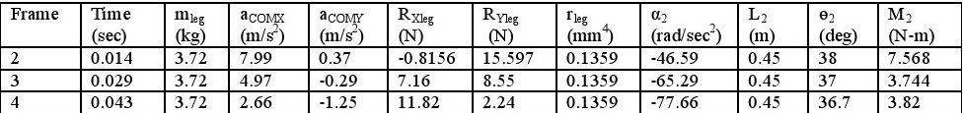

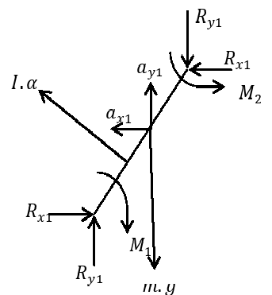

Fig 1.1 Resolved forces and moments on a left leg segment during swing phase

CHAPTER 2
LITERATURE REVIEW

Jobin and et al[1] (2014) conducted the mathematical modeling and analysis of human locomotion and utilized it for developing lower support limb for afflicted subjects. Special emphasis was given to average value based approach in the development of mathematical model for human locomotion by suitably modifying the infinite series.
Sai K banala and et.al [2]worked on “Gravity Balancing Leg Orthosis And Its Performance Evaluation” proposed a device to assist persons with hemi paresis to walk. The device was passive and has simple patient-machine interface.
Jerry E Pratt and et.al [3] (2004) worked on The RoboKnee: An Exoskeleton for Enhancing Strength and Endurance during Walking” and developed a one degree of freedom exoskeleton called RoboKnee. In RoboKnee, user intent is determined through the knee joint angle and ground reaction forces.
Kenton R. Kaufman and et.al [4] (1996) worked on “Energy- Efficient Knee-Ankle Foot Orthosis: A Case Study” and improved the KAFO by providing an articulated knee joint system that reduces the metabolic energy requirements during gait. This orthosis provides knee stability during stance while allowing free knee motion during the swing phase of gait.

CHAPTER 3
EXPERIMENTAL METHODOLOGY
The structural frame is to be made with aluminum alloys as an effort to reduce the weight ofthe entire system and also considering its strength properties. This frame is attached at the hip portion and extends to the foot. Proper tightening of the fixture is obtained using belts attached to the frame. These belts also tighten the upper body in a criss-cross manner to improve balancing of the subjects. Fig. 1 show the schematic diagram of the proposed exo-skeleton system.The attached exoskeleton is then operated with the help of servo motors and pneumatic controllers. The ability of servo motors to produce desired angle of rotation is made use in this design. Research results have proved that The results of the static analysis of knee angles are found to be:
- 55 degrees during slow walking mode
- 48 degrees during normal walking mode
- 35 degrees in the fast walking

and the hip angles are found to be:
- 25 degrees for slow walking
- 20 degrees for normal walking
- 15 degrees for fast walking

Servo motors are attached at the hip, knee and ankle positions of each leg with suitable
- pneumatic controllers. The series of motion of these motors are done similar to the motion of these regions in the normal human gait cycle, ie; hip followed by knee, ankle, knee, ankle and hip in the sequential order. The supply requirements of the servomotor are elected on the basis of the required torque output for the concerned subject. For the analysis, a male subject of 5.5 ft height and 75 kg weight is to be considered. The analysis is such that the two phases in the normal human gait cycle which are the stance phase and the swing phase are examined. The weight of the power supply for each servo motor can be managed by connecting cells of required ratings in a light packed design and are fitted in a scattered manner near the position of corresponding servo motors. The entire weight of the device and also the body weight of the afflict is to be balanced with the help of support sticks which can be held between the arm and upper body. Accelerometers are attached in each wrist, so that when an arm is in swing phase, corresponding limb is initiated with motion, ie; right arm for left limb.

CHAPTER 4
DESIGN PROCESS
4.1 PROBLEM IDENTIFICATION
The problem identified was regarding the condition of partially paralyzed afflicts in the society who are devoid of self commutation capacity making use of their paralyzed body region.
4.2 PROBLEM DEFINITION
Partially paralyzed afflicts are devoid of self commutation capacity are facing a serious problem in the society which leads to the discomfort able existence of this community in the society.
4.3 DESIGN FUNCTIONS AND CONSTRAINTS
The following observations were obtained :
- The device has to impart commutational ability in the subject.
- The device has to keep the afflict in a stable posture.
- Has to induce hip, knee and angular movements perfectly one after the other.
- The frame material should be weightless as well as strong enough to withstand heavy load.
- Proper weight balancing and posturing.
- Weight of the dc power source for operating Servo motor.
- Deviation from normal human gait .
- Discomfort in operating the support stick.
4.4 DATA COLLECTED
- This obtained value of angles of swing can be achieved by using servo motors.
From the army research results, it was observed that ;
- Hip moment was 1.15 Nm/kg
- Knee moment was 0.46 Nm/kg
- Ankle moment was 1.73 Nm/kg
- Power required at hip :1.8 W/kg
- Power required at knee : 0.6W/kg
- Power required at anle :4.40W/kg
With this collected data, servo motors of required ratings are selected

4.5 IDEATION
In the ideation session , the team were discussing various frame materials and other additive designs that can be incorporated.
- Aluminium , carbon fibre were the materials in the discussion
- Stepper motor, servo motor , pneumatic pistons were discussed for motion inducers.
- Discussions were held on weight balancing of the entire structure.
- There was a suggestion to add brain signal controller to induce motion whenever thought.
- The team thought of developing a different gait cycle for the afflicts to reduce complexity of mechanism
4.6 PRELIMINARY DESIGN
- Aluminium was selected as the frame material, due to its :
wide availability, low price , high strength , reduced wear.
- Servo motors were selected as the motion inducers due to its:
- Small size and weight (17 g)
- Reasonable torque (3kgf-cm)(6V)
- Low voltage requirement (4.8-6V)
4.7 DETAILED DESIGN
- To reduce the complexity and cost in weight balancing, a walker with castor wheels and controllers to operate the motor are provided.
- Brain signal controlling is avoided and is kept for future upgrade.
- Manual controlling in the support sticks is preferred.
- The device follows normal gait of humans enabling the afflict to sit and wake.
- The design is expected to develop at an estimate of RS 50000/-
4.8 DESIGN FOR POSTURING, SAFETY,RECOVERY
The design considering its constraints and functions , was developed for proper posturing and safety of the user.
The user who uses the newly proposed design should have to undergo stance phase during his motion which he will not encounter in a wheel chair. The posturing ability is provided with the help of walker with castor wheels.
Accurate and timely motion of the system is obtained using servo motors and since the afflict is supported using walker with castor wheels, chances of user falling down is voided.
The design is also meant for the afflicts to recover from the condition of paralysis by self therapy of the paralyzed portions.
4.9 AESTHETICS AND ERGONOMICS
The design was framed considering good space for ergonomics , since it has to be physically appreciable and attractive in the market. The design has a lighter and sporty look
The design is ergonomically designed in such a way that it is light weight and strong , since the proposed frame material is aluminium
The width of the hip region of the proposed device can be increased to 0.2 inches by using an extra plate in the side support.
4.10 STANDARDISATION
The proposed design is designed considering a partially paralyzed afflict of 6 ft height and 80 kg weight. The design is such that it can also be used by another afflict of almost same height and more obese than the former.
The design is proposed to be made of standard aluminum material and servo motors with standard ratings of input current and torque
4.11 PROTOTYPING
The proposed design can be made a prototype with standard aluminum frame material and motion can be established by standard rated servo motors at an estimate of RS 50000/-
4.12 ANALYSIS
Analysis was done on natural human locomotion ( stance phase and swing phase) and the following results were obtained
- Hip angle at normal walking is 20 degree
- Knee angle at normal walking is 48 degree
- Hip angle at slow walking is 25 degree
- Knee angle at slow walking is 55 degree
- Hip angle at fast walking is15 degree
- Knee angle at fast walking is 35 degree
This obtained value of angles of swing can be achieved by using Servo motors.
From the army research results, it was observed that ;
- Hip moment was 1.15 Nm/kg
- Knee moment was 0.46 Nm/kg
- Ankle moment was 1.73 Nm/kg
- Power required at hip :1.8 W/kg
- Power required at knee : 0.6W/kg
- Power required at ankle :4.40W/kg
- These results are considered in the design process.
4.13 COMMUNICATION
Various analysis results were discussed with experts of the field and required amendments were brought in the design.
4.14 DESIGN MODIFICATION
The design is expected to be modified with myo electric signals that control the operation of servo motors

CHAPTER 4
RESULTS AND DISCUSSIONS
The tabulated knee angular displacement values are divided into three primary sectors viz., sector A, sector B and sector C. These primary sectors are then subdivided into secondary and tertiary sectors. Average value based method is applied to each sector and three equations are formulated using following approach
P₁*(B_{avg}A)+P₂*(∆B_{avg}A)+P₃*(∆2B_{avg}A) = distance covered corresponding to Primary Sector A
The constants P1, P2 and P3 represents the physical parameters of the system, (∆B_{avg}A ) is the first variational change that corresponds to secondary sector, ∆2 B_{avg}A is the second variational change corresponds to tertiary sector.
Simillarly for Primary Sectors B and C
P₁*(B_{avg}B)+P₂*(∆B_{avg}B)+P₃*(∆2B_{avg}B) = distance covered corresponding to Primary Sector B
Here the relation between a dependent variable and independent variable is not accurately available from theory. The optimum form of relation and the ‘best ‘ set of numerical coefficients, given a set of measured data is found using MATLAB. The values of the constants are obtained by solving the above equations. For the subject consider for experimentation we obtain the values of P1,P2,P3
P1*(Base _{Avg}X) + P2*(First change in Base _{Avg}X)+P3*(Second change in Base AvgX) = distance covered in Primary Sector X

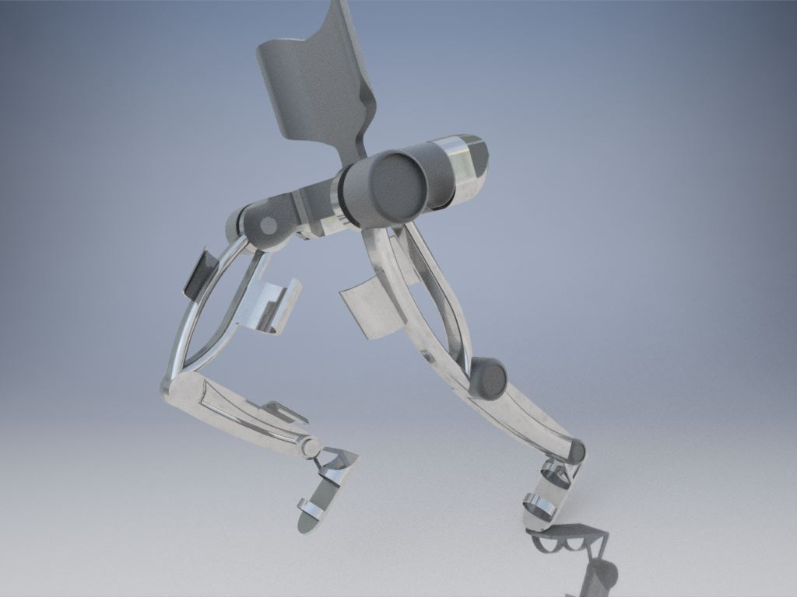
Fig 4.1

3D Design of the proposed walk assistor
CHAPTER 5
CONCLUSIONS
High resolution camera was used to record the gait cycle positions and the angular displacement, angular velocities and angular accelerations has been measured and calculated. Using the data collected from the recorded video, an infinite series linear mathematical model has been developed and validated successfully. Forces and moments are calculated using newtons equations of motion. Knee moment is also calculated using average value based method and both methods show the similarity in results. Practical realization of the model developed has been performed by fabricating simple and cheap walking assistive device and its control techniques. The assistive device developed is simple, cheap and robust. Walking experiment is performed using fabricated walking assistive device and the gait movement were recorded using camera. The analysis results shows that a good match between natural human gait cycle and gait cycle with walking assistive device
REFERENCES

[1].T Hayashi,H Kawamoto and Y Sankai “ Control Method of Robot Suit HAL working as operator’s Muscle using Biological and Dynamical Information” IEEE /RSJ International conference on Intelligent Robots and Systems 2005.
[2] Adam Zoss, H. Kazerooni, Andrew Chu “On the Mechanical Design of the Berkeley Lower Extremity Exoskeleton (BLEEX)” 2005 IEEE/RSJ International Conference on Intelligent Robots and Systems.
[3] Takahiko Nakamura and Kazuhiro Kosuge “Model-based walking support system with Wearable Walking Helper” Proceedings of the 2003 IEEE International Workshop on Robot and Human Interactive Communication Millbrae. Caliiomia. USA, Oct. 31 -Nov. 2.2003
[4]Sai K. Banala, Sunil K. Agrawal, Abbas Fattah “Gravity Balancing Leg Orthosis And Its Performance Evaluation”.
[5] Jerry E. Pratt, Benjamin T. Krupp, Christopher J. Morse and Steven H. Collins” The RoboKnee: An Exoskeleton for Enhancing Strength and Endurance during Walking” Proceedings of the 2004 IEEE, International Conference on Robotics & Automation
[6] Kenton R. Kaufman, PHD,S.E. Irby, MS,J.W Mathewson, MD,R.W. Wirta,D.H. Sutherland, MD “Energy- Efficient Knee-Ankle Foot Orthosis: A Case Study” jpo 1996
[7] Irby SE. A digital logic-controlled electromechanical freeknee brace, MS1 Thesis, San Diego State University, San Diego, Calif., 1994
[8]Kaufman KR, Irby SE, Wirta RW, Us sell DW, Mathewson JW, Sutherland DH. Knee-ankle-foot orthosis for free-knee gait. Second world congress of biomechanics. Amsterdam, The Netherlands, July 10-5, 1994:280.
[9] Malcolm LL, Sutherland DH, Cooper L, Wyatt M. A digital logic-controlled electromechanical orthosis for free-knee gait in muscular dystrophic children. Orthop Transactions 1980;5:90.
[10] Ernest O Doebelin “Measurement Systems” Application and Design page no. 90-110

INTERACTION AND DISCUSSIONS

- What is the significance of a servo motor?
The significance of a servomotor is that the angle of rotation of the motor can be controlled than other motors.
- What is the significance of this assistive device over wheelchairs?
Partially paralyzed people are usually undergone physiotherapy to develop a chance of recovery and to prevent further paralyzation. This device would help them to commute their own along with self therapy of the paralyzed parts

